Spring and Mass Oscillations

Equipment

|  |  |  |
| --- | --- | --- |
| 1 | Mass & Hanger Set | ME-8979 |
| 1 | Motion Sensor | PS-2103A |
| 1 | Force Sensor | PS-2189 |
| 1 | Density Set | ME-8569 |
| 1 | Spring Set | ME-8999 |
| 1 | Braided String | SE-8050 |
| 1 | 90 cm Rod | ME-8738 |
| 1 | 45 cm Rod | ME-8736 |
| 1 | Multi-Clamp | ME-9507 |
| 1 | Large Rod Base | ME-8735 |
|  | Required but not included: |  |
| 1 | Balance | SE-8723 |

Introduction

The period of oscillation, T, for a mass on a spring is given by

$T=2π\sqrt{\frac{m}{k}}$ (1)

where m is the oscillating mass and k is the spring constant.

In this lab, the Motion Sensor measures the position of the oscillating mass, and the Force Sensor is used to determine the spring constant. The period of oscillation is measured, and compared to the theoretical value. 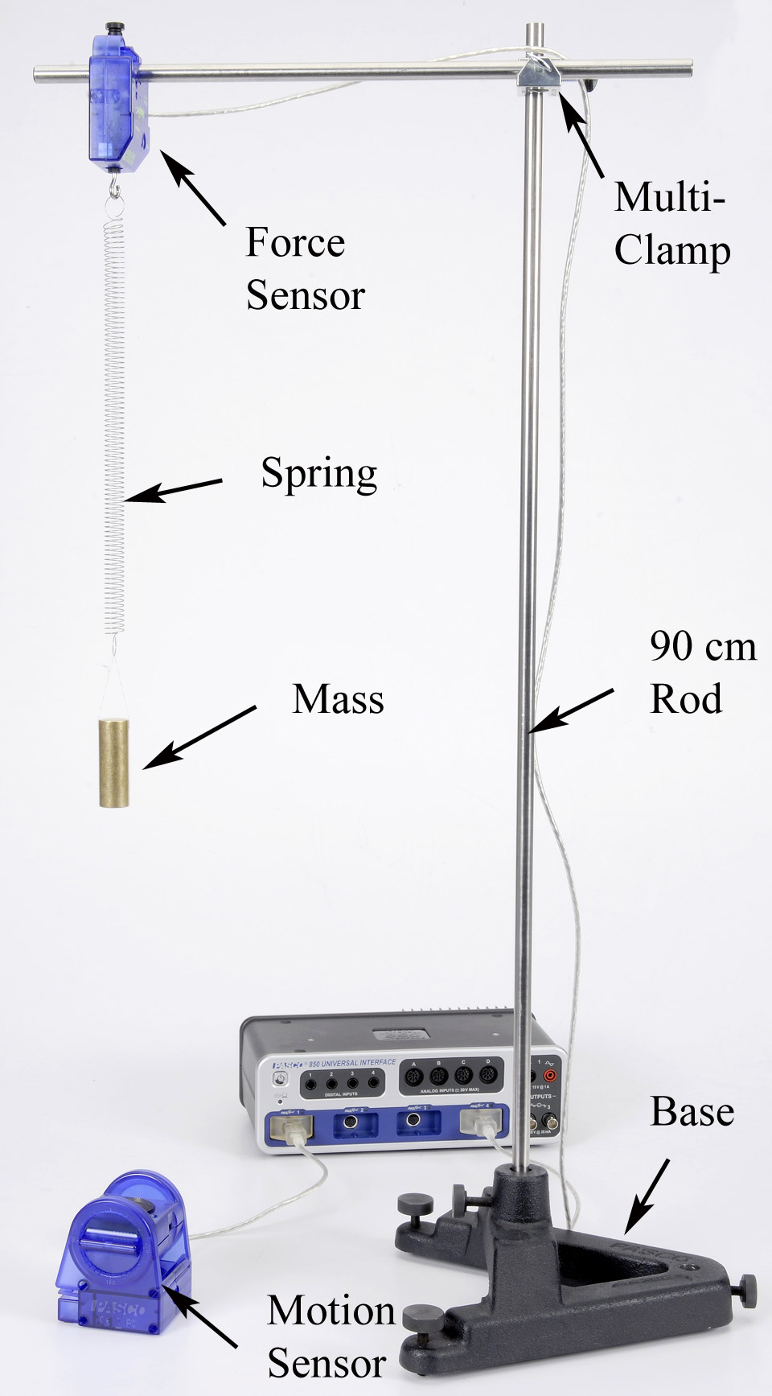 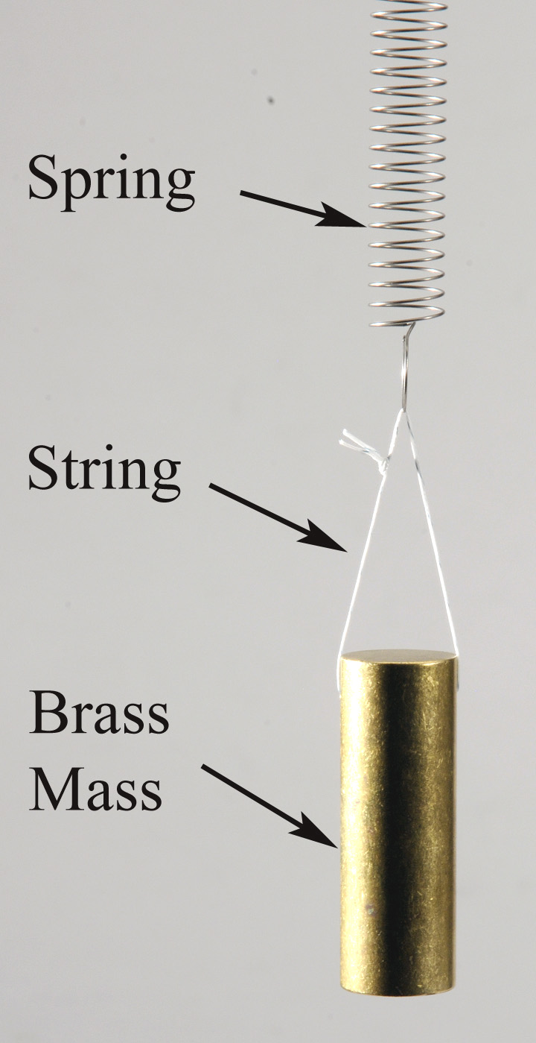 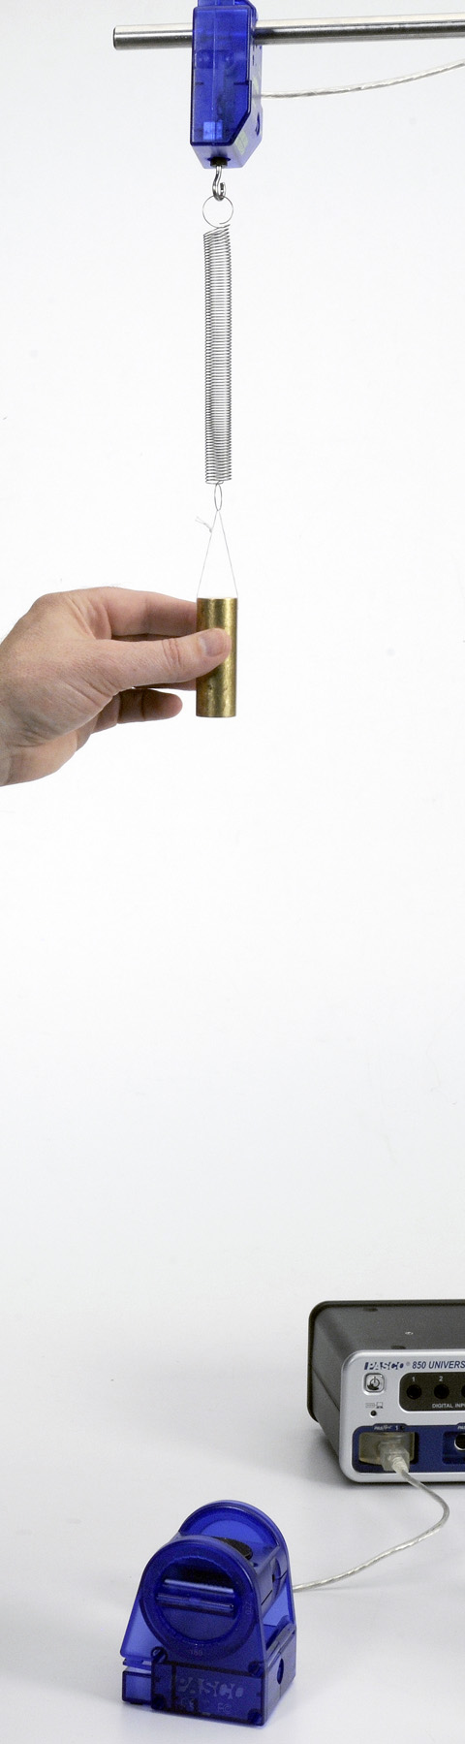

Figure 1: Spring & Mass Oscillation Figure 2: Oscillating Mass Figure 3: Spring Constant

Setup

1. Use the large base, rods, and multi-clamp to support the Force Sensor as shown in Figure 1.
2. Plug Force Sensor into port P4, and tare the sensor.
3. Position the Motion Sensor as shown and plug it into port P1.
4. In PASCO Capstone, set the Common Sample Rate to 50 Hz. Create a graph of Position vs. Time.
5. Aim the Motion Sensor upwards, towards the Force Sensor.
6. Use a balance scale to measure the mass of the brass cylinder from the Density Set.
7. Choose one of the long, stronger springs from the Spring Set. The spring with the larger spring constant should have a spot of red paint at one end. Measure the mass of the spring.
8. Tie a short piece of string through the hole in the brass mass as shown in Figure 2. Hang the mass, string, and spring assembly from the Force Sensor hook.
9. Allow the mass to oscillate and take some practice data. Adjust the Motion Sensor if necessary to get smooth continuous data.

Measuring T

1. Click on the properties (gear) icon for the Motion Sensor in the Hardware Setup window. With the mass hanging at equilibrium (not moving), click Zero Sensor Now.
2. Displace the mass from equilibrium by several centimeters, and allow it to oscillate.
3. Take around five seconds worth of data.
4. Use the coordinates tool to find the period, and record it.

**Note:** You can also use a sine fit to find the angular frequency, ω, and then use that to calculate the period.

1. Take data for both large and small oscillations. Is there a difference?
2. Calculate the average value of the period. Repeat several times until you get a good, solid value. Record your average.

Measuring the Spring Constant (k)

1. 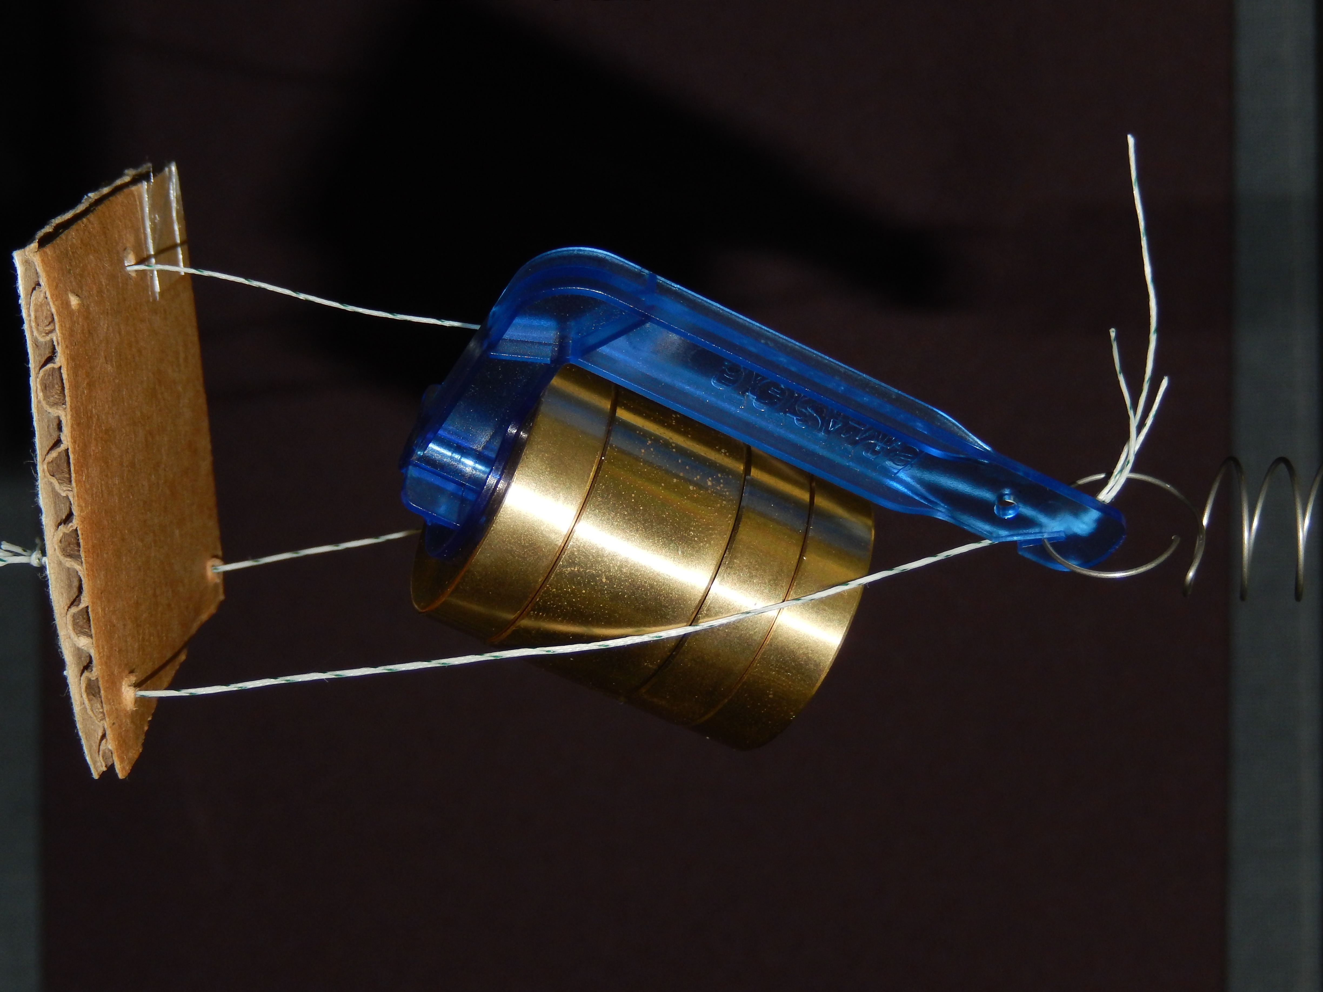Remove the brass mass and replace it with a mass hanger loaded with 250 g as shown in Figure 3. Better results will be obtained if you attach a small cardboard reflector as shown in Figure 4. It is attached to the spring rather than the mass hanger since the mass hanger rotates downward slightly as more mass is added.
2. Arrange the Motion Sensor so it is directly below the target.
3. In Capstone, change the Common Sample Rate to 20 Hz. Change the Sample Mode to Keep Sample.

Figure 4: Adding a Reflector

1. Create a graph of Force vs. Position, a Digits display of Force, and a Digits display of Position. On the Position axis of the graph, select a QuickCalc of negative Position.
2. Click Preview. Wait until the mass has stopped moving up and down (the Force number is constant) and click Keep Sample. Do not click Stop.
3. Remove 50 g and after the mass stops moving, click Keep Sample. Repeat until all 250 g has been removed. After you click Keep Sample for the case that all 250 g have been removed, click Stop.
4. On the graph, add a linear fit. From Hooke's Law, F = kx, so the slope of the line is the Spring Constant, k. Record the value and include the uncertainty.

Analysis: Calculating T

1. Use Equation (1) to calculate the theoretical period of the mass and spring.
2. For an ideal system, the entire mass would be in the oscillating object, and the spring would have zero mass. In reality, the spring has some mass, too. But not all of the spring is moving, so how much do you include? It can be shown that one-third of the mass of the spring should be added to the mass of the oscillating object.
3. Re-calculate the period using the adjusted mass. Does it change your answer? Does it give you a better answer?
4. Compare your final theoretical value for the period to the value you measured with a % error.

Questions

1. In general, what happens to the period of a spring and mass when you increase the mass?
2. In general, what happens to the period of a spring and mass when you increase the spring constant?
3. In general, what happens to the period of a spring and mass when you increase the amplitude of the oscillation?
4. In general, what happens to the period of a spring and mass when you increase gravity?